FEN TO FELL 2024
20th to 23rd June 2024

BOOKING FORM

PLEASE COMPLETE IN BLOCK CAPITALS

Please Note: You are signing up for a 4x4 driving adventure from the lowest to highest roads in the UK via off road routes through the Peak District, Yorkshire Dales and North Pennines. The days may be long, so if you are expecting a relaxing tour of England with 5-star accommodation, please read no further and take a look at the latest offerings from Abercrombie & Kent. If on the other hand you want a real adventure, you’ve come to the right place!

Itinerary:

Thu 20th June 19:00 hrs - Meet at The Admiral Wells (UK’s lowest pub) for dinner
Overnight at the Premier Inn - Peterborough (Hampton)

Fri 21st June Peterborough to Peak District via UK’s lowest point and highest green lanes
Overnight at campsite

Sat 22nd June Peak District to Yorkshire Dales via highest green lanes and Buttertubs Pass
Dinner at the Tan Hill Inn (UK’s highest pub). Wild camp outside (toilet & shower available)

Sun 23rd June Yorkshire Dales to North Pennines & Great Dun Fell (UK’s highest track)
14:00 hrs – Depart for home

Please Note:

As this is a vehicle adventure through challenging terrain and therefore subject to the weather, mechanical breakdowns and route conditions, Max Adventure Ltd have the right to alter the itinerary at any time to ensure the overall safety of the team. Any alterations will be discussed in advance of changes, but a flexible approach to the itinerary is therefore required by all those taking part.

Start Accommodation:

The original plan was for Max Adventure to arrange a group booking at the Premier Inn hotel in Peterborough for the night of Thursday 20th June. For some reason, Premier Inn increase their prices by 50% for a group booking as opposed to an individual one! Rather than pass this cost on to the client, we ask that each team books their own room directly.

Date: Thursday 20th June 2024

Hotel: Premier Inn Peterborough (Hampton)

Address: 4 Ashbourne Road, Off London Road, Hampton PE7 8BT

What 3 Words: ///partner.expanded.genius

Rate: Advance Rate – Recommended as fully refundable with free cancellation up to 28 days before arrival

Breakfast: Recommend selecting, as it will set you up for the day

Website: https://www.premierinn.com/gb/en/hotels/england/cambridgeshire/peterborough/peterborough-hampton.html?cid=GLBC_PETHAM

Drivers / Co-Drivers:

Driver 1 (Primary Contact)

Name (Mr/Mrs/Miss/Ms) ___________________________________________________________________________

Known As __________________________________________________________________________________

Address __________________________________________________________________________________

Mobile No __________________________ Email ______________________________________________

Driver 2 (Minimum of 2 Drivers per Car)

Name (Mr/Mrs/Miss/Ms) ___________________________________________________________________________

Known As __________________________________________________________________________________

Address __________________________________________________________________________________

Mobile No __________________________ Email ______________________________________________

Driver 3

Name (Mr/Mrs/Miss/Ms) ___________________________________________________________________________

Known As __________________________________________________________________________________

Address __________________________________________________________________________________

Mobile No __________________________ Email ______________________________________________

Driver 4

Name (Mr/Mrs/Miss/Ms) ___________________________________________________________________________

Known As __________________________________________________________________________________

Address __________________________________________________________________________________

Mobile No __________________________ Email ______________________________________________

Vehicle:

4x4 Vehicle: Year: ___________________

Make: ___________________ Model: ____________________

Engine Type: ___________________ Gearbox Type: ____________________

It will be the requirement of each team to carry appropriate spares for their own vehicle. We will advise as to what the most appropriate spares are, along with a comprehensive kit list.

The Road to Recovery:

Driven to Extremes was founded in 2017 by expedition specialists Max Adventure in support of injured military veterans by taking them on challenging vehicle adventures to aid their recovery from PTSD. Whereas some activities such as Atlantic rowing can allow too much thinking time, vehicle expeditions can cross continents in a matter of days. The intense exposure to new and exciting experiences within a challenging team-based environment helps push horrific memories to the back of their minds.

We ask that each team therefore raises a minimum of £100 in support of veterans that will join us on Driven to Extremes Adventures and Expeditions. Each team will be asked to set up a Just Giving site, proceeds of which will go into a dedicated bank account to be spent on veterans.

Branded Adventure Clothing Available:

Selected for their suitability on Driven to Extremes FEN TO FELL, we have a range of branded clothing available:

Baseball Caps /

Woolly Hats

£11.95

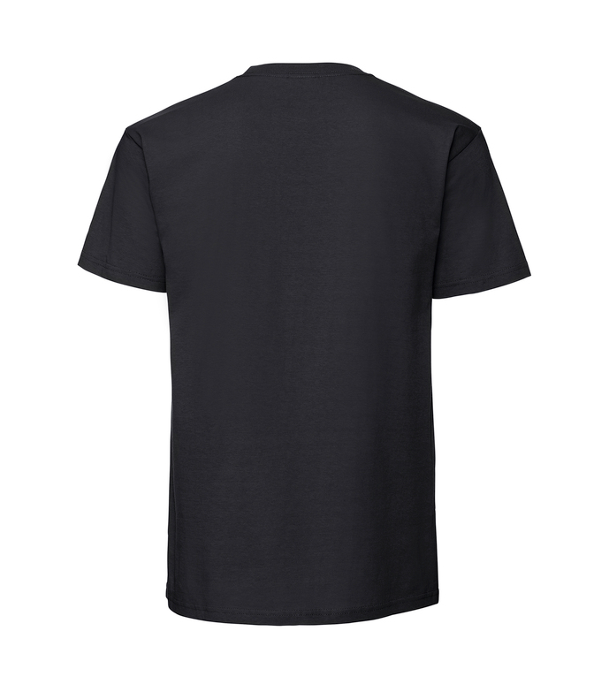
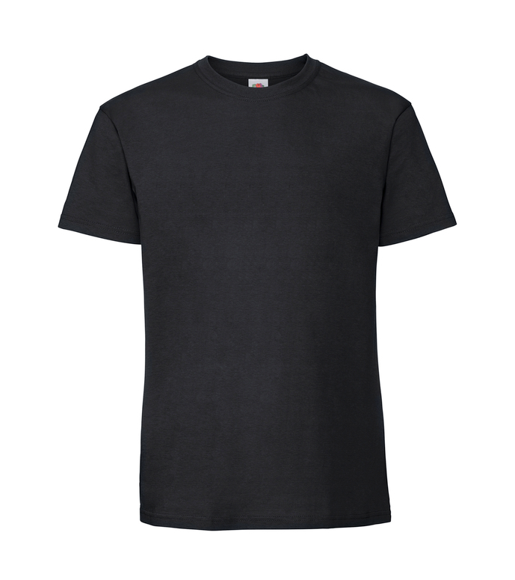

T-Shirts
£19.95

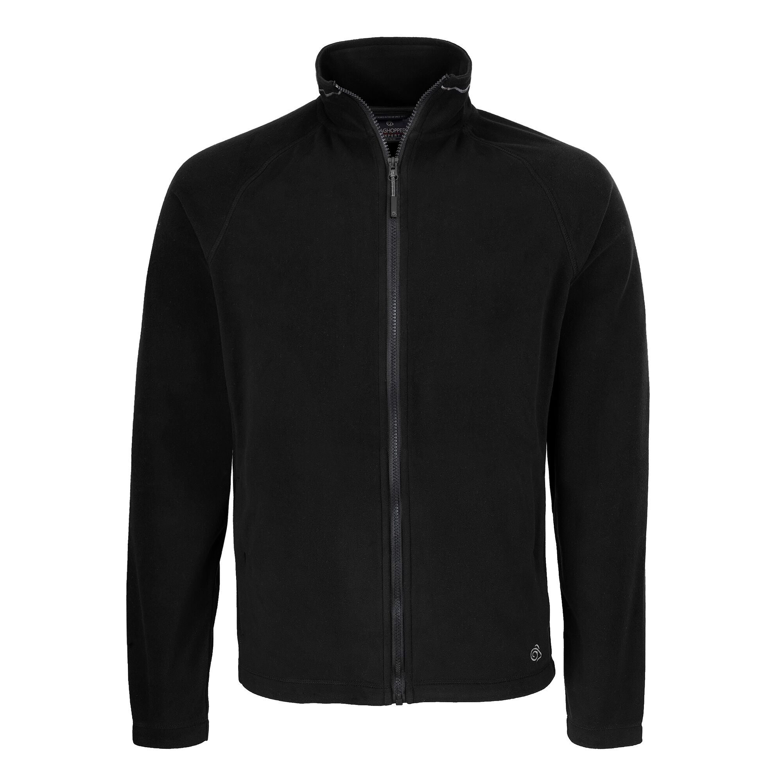
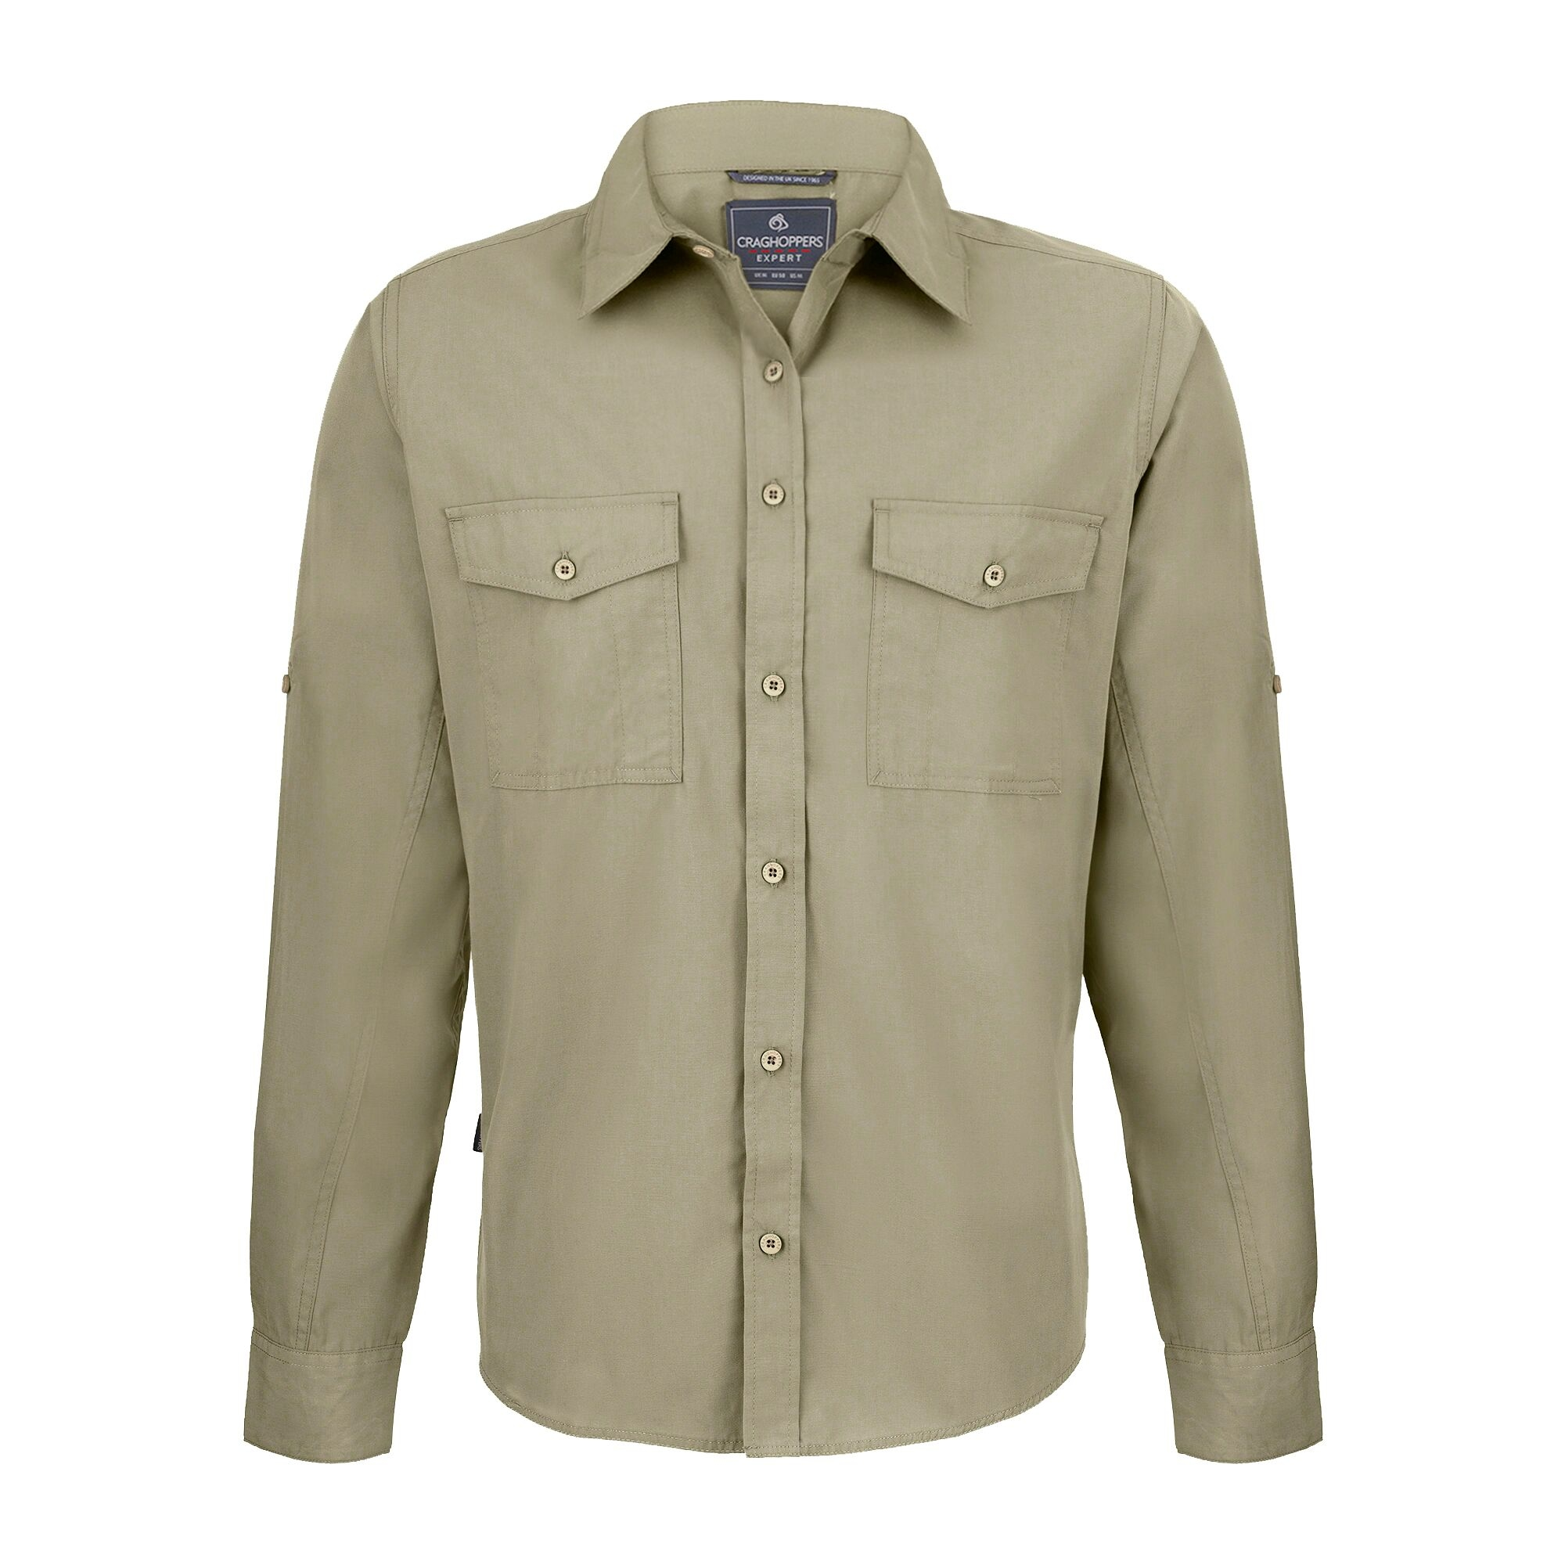
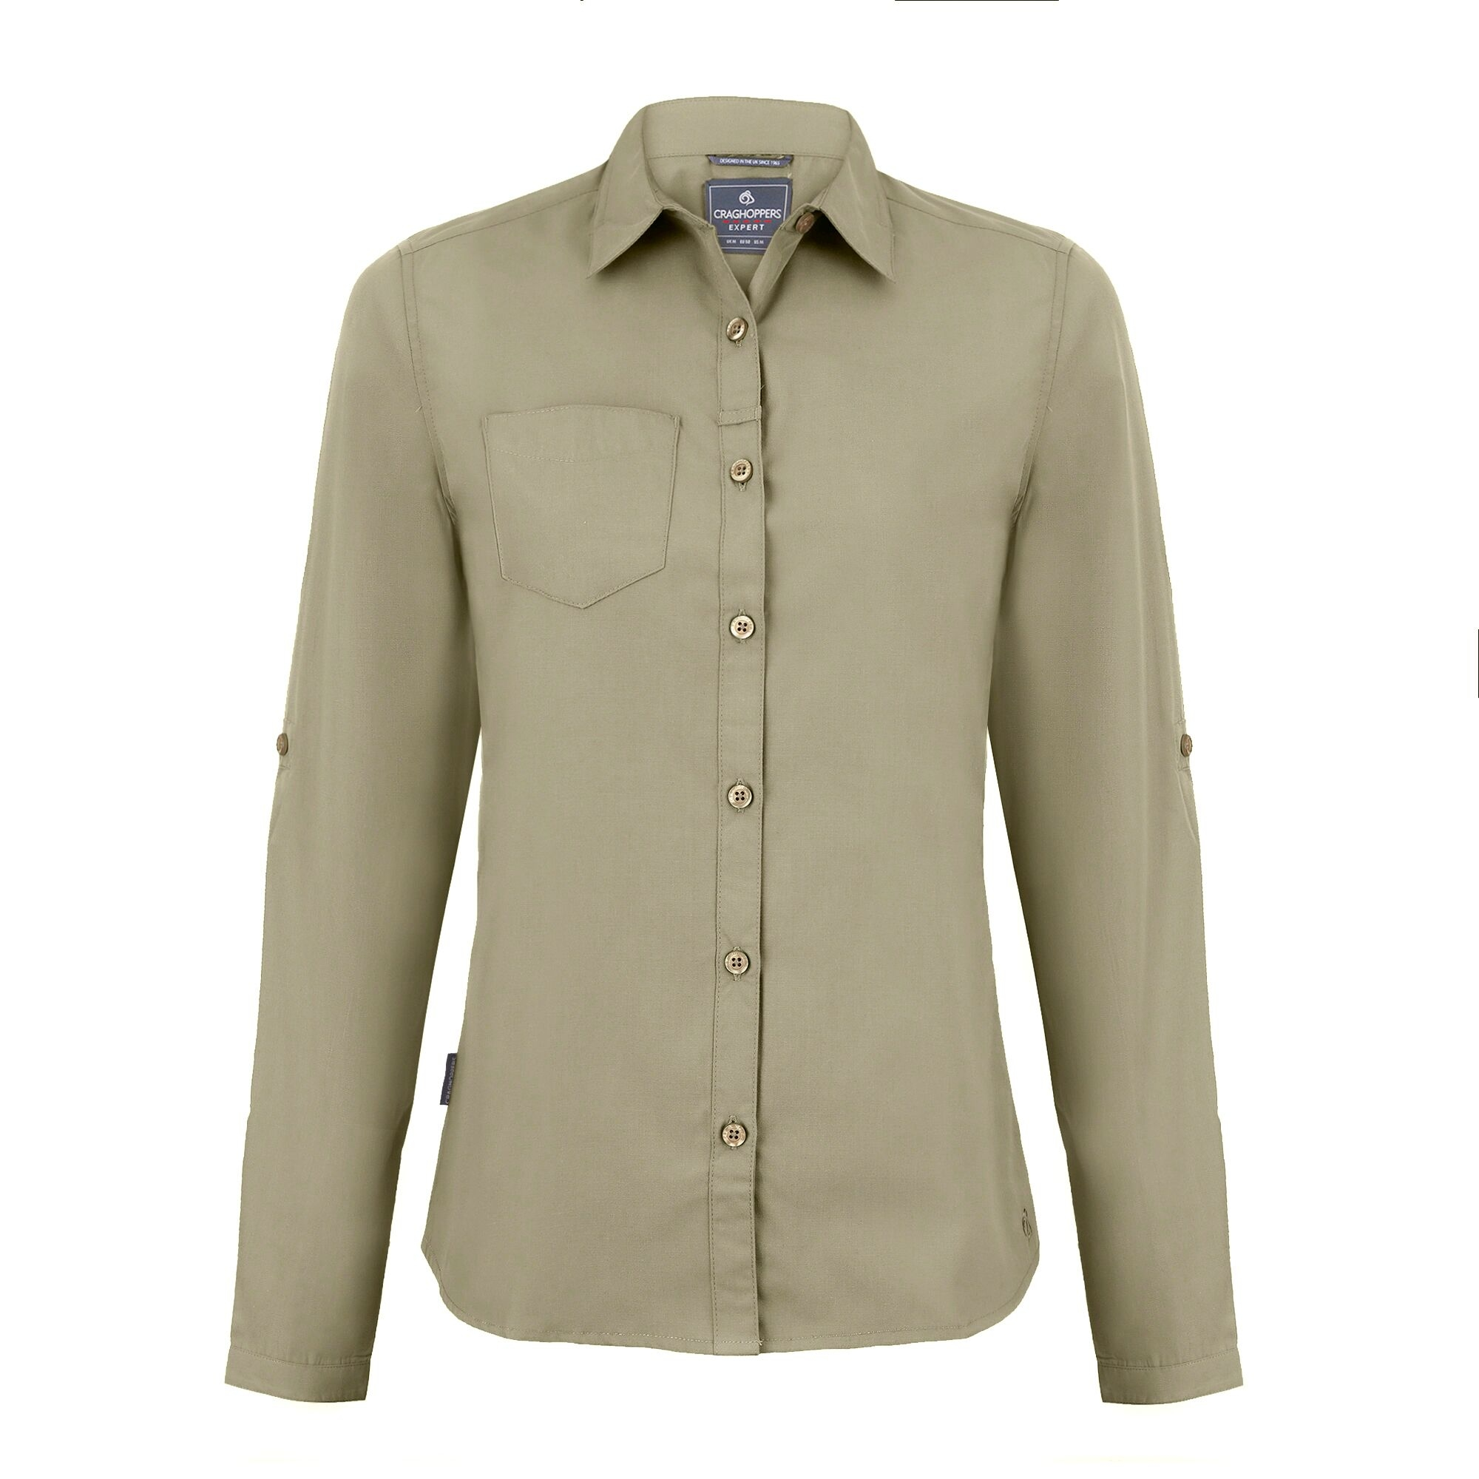
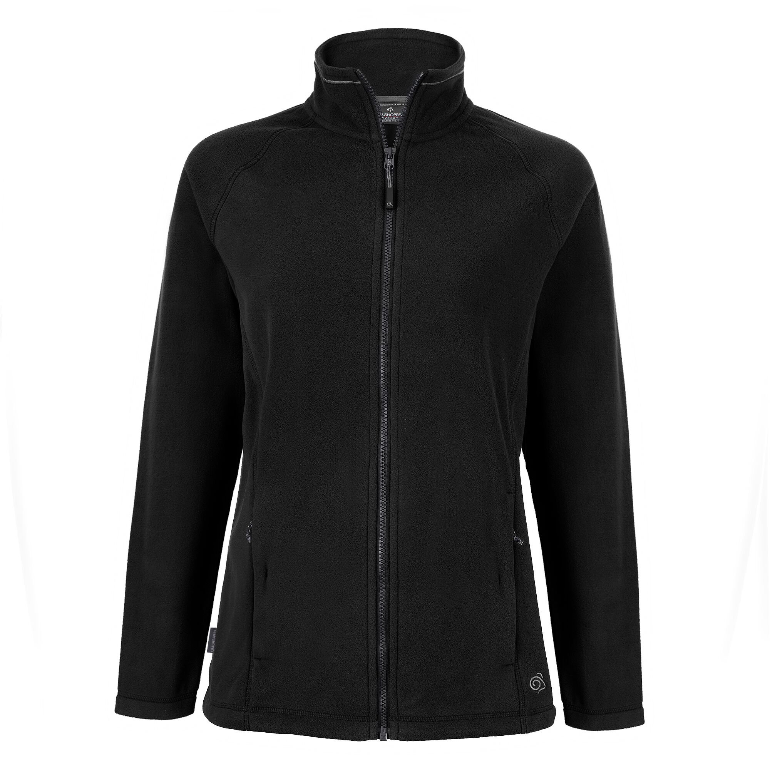

Shirts
£39.95

Fleeces
£49.95

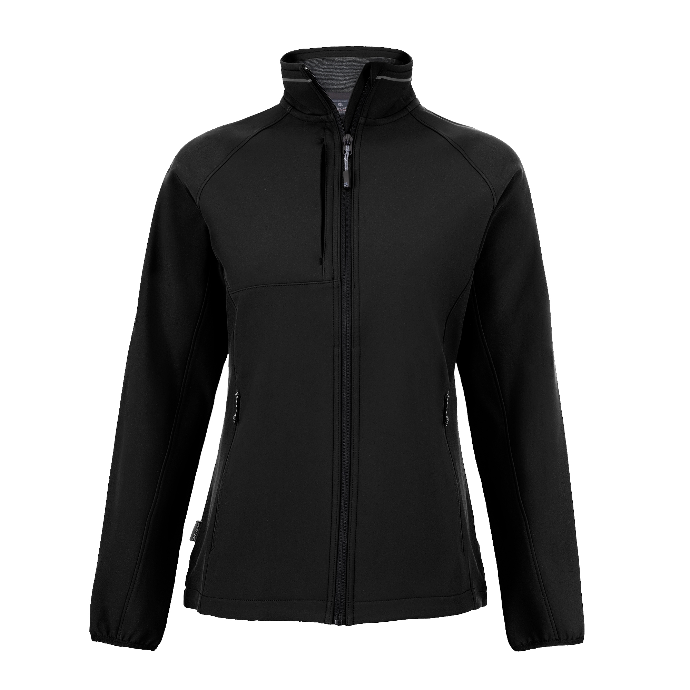
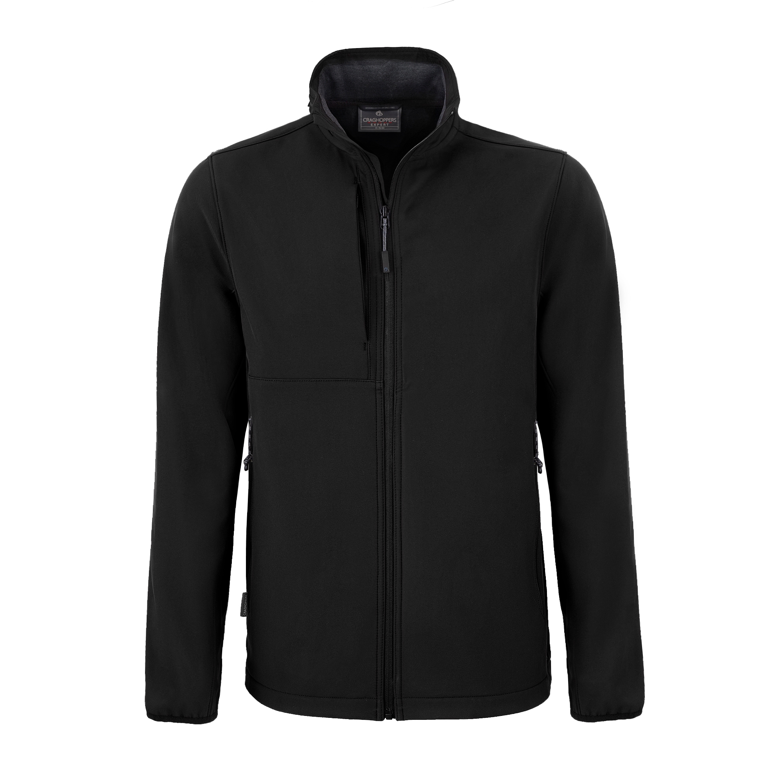

Softshell Jackets
£59.95

All prices exclude postage & packing, or items can be handed out at the start of the adventure.

BRANDED CLOTHING
UNISEX | XS | S | M | L | XL | 2XL | 3XL | 4XL | One Size
Baseball Cap
Woolly Hat
T-Shirt
MEN | XS | S | M | L | XL | XXL | XXXL
Shirt
Fleece
Softshell Jacket
WOMEN | 8 | 10 | 12 | 14 | 16 | 18 | 20
Shirt
Fleece
Softshell Jacket

Please indicate the numbers of each size required.

Entry Fee:

The entry fee per person includes…

- Professional support crew – Leader, Mechanic
- Expedition prepared 4x4 support vehicles (we aim for one 4x4 per 6 vehicles taking part)
- Expedition medical, mechanical, recovery & communication equipment (incl. satellite phones)
- 1 night campsite accommodation – 2 people sharing a tent*
- 1 night wild camp outside the UK’s highest pub (toilet & shower available) – 2 people sharing a tent*
- UHF radio hire – full vehicle kit
- Satellite mapping for smartphones

* Individual tent supplement available on request

The adventure starts in Holme, just south of Peterborough and finishes at the foot of Great Dun Fell in the North Pennines, following our descent off the mountain.

Early Bird Discount – Until 31st March 2024

No. in Car Entry Fee Deposit Balance

Drivers / Passengers Per Person Paid when Booking Paid by 31st May 2024

2 £ 249.00 £ 65.00 £ 184.00

3 £ 199.00 £ 50.00 £ 149.00

4 £ 149.00 £ 35.00 £ 114.00

HM Forces (Regular or Reserve / Serving or Veteran) – Until 31st May 2024

No. in Car Entry Fee Deposit Balance

Drivers / Passengers Per Person Paid when Booking Paid by 31st May 2024

2 £ 249.00 £ 65.00 £ 184.00

3 £ 199.00 £ 50.00 £ 149.00

4 £ 149.00 £ 35.00 £ 114.00

Standard Entry Fee – 1st April to 31st May 2024

No. in Car Entry Fee Deposit Balance

Drivers / Passengers Per Person Paid when Booking Paid by 31st May 2024

2 £ 279.00 £ 70.00 £ 209.00

3 £ 229.00 £ 60.00 £ 169.00

4 £ 179.00 £ 45.00 £ 134.00

If your application is accepted it is understood that the deposit is non-returnable in all cases, other than organiser’s negligence, cancellation of the event due to Force Majeure (circumstances beyond our control), or the event not reaching the minimum number of entrants required for it to take place (6 cars).

Confirmation of your successful application, along with further information, will be emailed to you. If your application is not successful, your deposit will be returned.

The remaining balance must be received by the date listed above, after which date any entry not paid in full will be deemed null and void. No refund will be given.

We are also offering a further £50 discount per team for introducing additional entrants that sign up to the adventure.

Payment:

Payment can be made by cheque payable to:

Max Adventure Ltd and sent along with this application form, or by BACS:

By BACS: Bank: Lloyds Branch: Bracknell
Sort Code: 30-91-11 Account No: 03558000

SWIFT / BIC: LOYD GB 21059 IBAN: GB52 LOYD 3091 1103 5580 00

Reference: Please make any BACS payments with the reference
F2F24 (followed by your name)

Your participation on the adventure can only be guaranteed upon receipt of payment.

Public and Products Liability Insurance:

The organisers at Max Adventure Ltd have a £2.5 million Public and Products Liability Insurance in place supported by Tasker & Partners Ltd. This policy is wholly unconnected with the vehicle insurance requirements for each entrant; vehicle insurance cover remains the responsibility of the entrant.

Indemnity:

I have read the application form and any regulations issued for the adventure and agree to be bound by them and by any additional instructions issued by the organisers.

I am aware that this adventure may involve long days. I confirm that I am aware of the endurance element and have taken that into account when applying. I am aware that any routes are driven at my discretion.

In consideration of the acceptance of this entry or of my being permitted to take part in the adventure, I agree to save harmless and keep indemnified any sponsor or partner of the event, Max Adventure Ltd, the organisers, such person, persons or body as may be authorised to promote or organise this adventure and their respective officials, servants, representatives and agents from and against all actions, claims, costs, expenses and demands in respect of death or injury to myself / my crew howsoever caused arising out of or in connection with this entry or my taking part in this adventure, and notwithstanding that the same may have been contributed to or occasioned by the negligence of the said bodies, their officials, servants, representatives or agents.

Furthermore, in respect of any parts of this adventure on the ground where third party insurance is not required by law this agreement shall in addition to the parties named above extend to all and any other entrant(s) and their servants and agents and to all actions, claims, costs, expenses and demands in respect of loss or damage to the person or property of myself, my driver(s), passenger(s), mechanic(s), or associated personnel.

I declare that the vehicle hereby entered is roadworthy and the use of the vehicle will be covered by insurance as required by the law, which is valid for such part of this adventure as shall take place on roads as defined by the law.

Communications & Safety:

We ask that you agree to share your WhatsApp contact details with other members of the adventure via a dedicated Fen to Fell 2024 WhatsApp group. This allows the support crew to quickly and easily share information with the whole team.

You will be required to subscribe to the Ordnance Survey OS Maps app in order to navigate the route via your smartphone. This can be currently be purchased for £6.99 for 1 month, or £24.49 for 1 year.

OS Maps https://osmaps.com

Entry Form – Fen to Fell 2024:

If you wish to take part in Driven to Extremes Fen to Fell 2024, please sign below to confirm that you accept the terms and conditions outlined above.

Driver 1 Date __________ Name __________________________ Signed ________________________________

Driver 2 Date __________ Name __________________________ Signed ________________________________

Driver 3 Date __________ Name __________________________ Signed ________________________________

Driver 4 Date __________ Name __________________________ Signed ________________________________

Pages 2, 4 & 6 of this form should be completed and sent to…

By Post Max Adventure Ltd, The Carpenters, Axminster, Devon EX13 7EB

By Email info@maxadventure.co.uk

Further Information:

For further information please contact Mac: Mobile: +44 (0) 7764 600 601
Email: info@maxadventure.co.uk

